The Independent Labour Party (ILP)
Efforts to get the ‘old gang’ of the TUC to break with their historic support for the Liberal party and support the idea of independent labour representation continued in the 1880s but to no avail. In fact, as we know, this did not finally happen until 1899/1900. But pressure for independent labour representation both in parliament and in Local Authorities persisted. Keir Hardie, a key figure in this endeavour, stood as an independent Labour candidature in the 1888 Mid Lanarkshire by-election. He had tried and failed to gain Liberal Party support for his candidature, and the experience convinced many of his fellow miners of the need for an independent party representing the interests of labour. This led to the creation of the Scottish Labour Party later in 1888. Hardie became the Party’s Secretary.

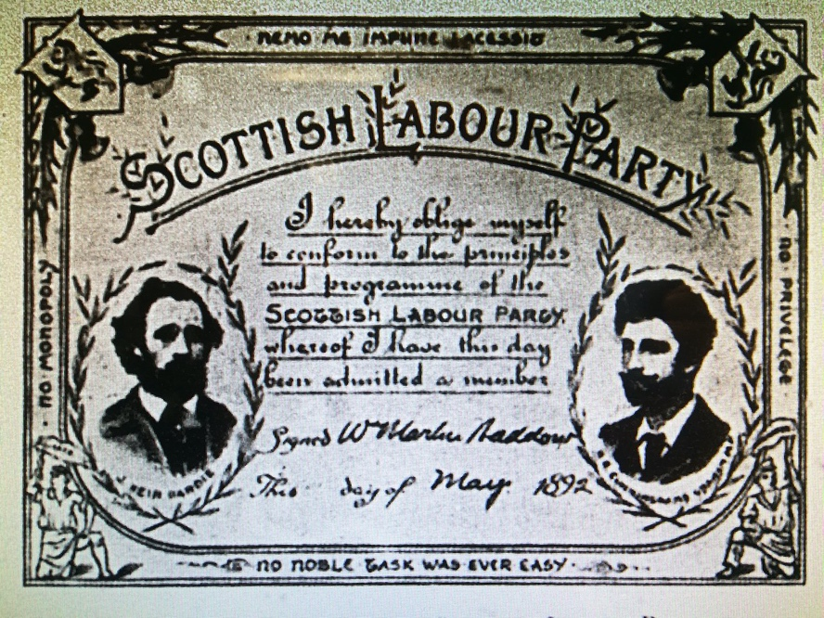

Efforts to secure the first independent Labour MPs continued and in the General Election of 1892 Keir Hardie, John Burns and Havelock Wilson secured election. These were the first working class MPs elected on a purely labour ticket, against Liberal and Tory opposition. John Burns and Havelock Wilson later became Liberals. Ben Tillett narrowly failed to win in West Bradford, standing as an independent labour candidate.

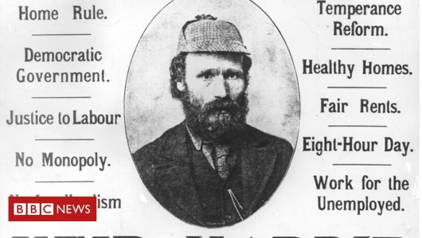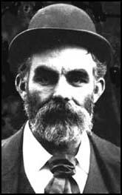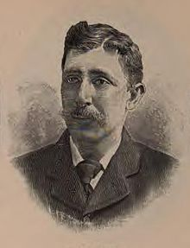
Keir Hardie, MP John Burns, MP Havelock Wilson, MP

Joseph Burgess, who edited the influential weekly Workmen’s Times, issued a call that same year, 1892, for people to sign up for a new independent labour party. Within a few months 2000 names had been submitted and local branches were being formed. Momentum gathered and a national arrangements committee was established linking the main independent left elements. A Conference was arranged for Bradford in 1893.

The Bradford Conference was attended by 120 delegates, the majority from the North (especially the West Riding of Yorkshire) and Scotland and included many young working men. Local northern SDF branches were represented but London SDF held aloof. Similarly, in the case of the Fabian Society, most of their provincial branches from north sent delegates but the leadership in London decided not to participate, although G. B. Shaw attended as an active participant. In addition to Shaw, most of the leading lights of the socialist movement were there including, Keir Hardie, John Trevor, (founder of the Labour Church Movement), Joseph Burgess, (editor of Workmen’s Times), and Robert Blatchford (the founder of the Clarion and its associated clubs). Eduard Bernstein was the fraternal visitor from the mighty German Social Democratic Party and editor of their paper, Vorwarts.

The Conference adopted a wide-ranging socialist programme of reform, guided by Edward Aveling (Karl Marx’s son-in-law) and G. B. Shaw. A high degree of local autonomy was adopted under a federal system of organisation but they agreed to establish a National Council representing all the regions. The first elected Secretary was Shaw Maxwell, and Keir Hardie was elected Chair. It had been hoped that this new Party could bring together all the main left bodies, but neither the Fabian Society nor the SDF chose to affiliate. Most of the northern Fabian sections voted with their feet and abandoned the Fabians in favour of the ILP. A few SDF branches did likewise. In 1894, the ILP decided against outside affiliations and shortly after, the Scottish Labour Party folded. The 1894 Conference also agreed to a smaller, directly elected National Council, and Tom Mann took over as Secretary. Although the basic structure was more centralised local branches retained considerable autonomy and frequently challenged the National Council.

In terms of an official organ for the new Party, Keir Hardie brought with him from the Scottish Labour Party, The Labour Leader and transferred it as the main voice of the ILP.

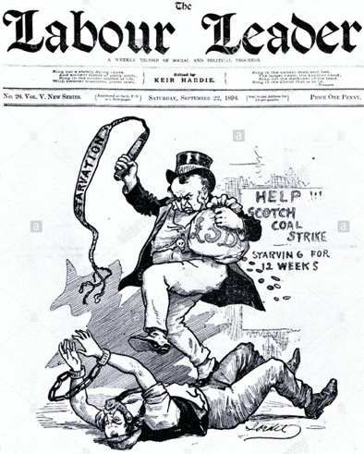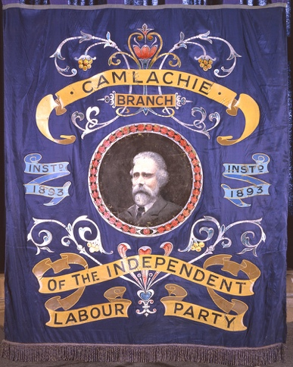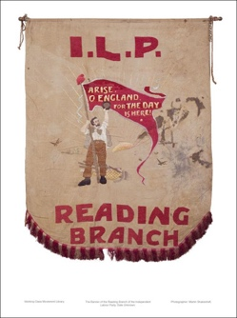

Regular paper of the I.L.P. Examples of ILP Banners

With high expectations, the ILP ran 28 candidates in the 1895 General Election but none was elected, and even Keir Hardie lost his seat. Whilst this marked an end to the unbridled optimism that had attended the Party's foundation, there was much fervour and enthusiasm in these years with speakers, educational and social activities in the branches and in the local communities. Women played a vital part, often linked into suffragette activities. National membership started around the 4000 mark but this was heavily concentrated in Lancashire, Yorkshire and Scotland. By 1895 some estimates suggest there were 10,000 fee-paying members with many more supporters.

The Clarion organisation, run by Robert Blatchford, was closely allied to the ILP and provided an important element of leisure, fun and popular propaganda that reached wider layers of workers, and won them over to the socialist cause. The Clarion was an important and popular paper in these years and when Blatchford re-printed many Clarion articles as the book Merrie England, it sold 750,000 copies in one year; an extraordinary achievement. Blatchford was a brilliant propagandist, and expanded the scope of the Clarion to include local clubs, Clarion Scouts, Clarion Cycle Clubs, Camera Clubs, Field Clubs and Houses that were forerunners of Youth Hostels, and a general interest in working class sport.

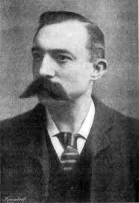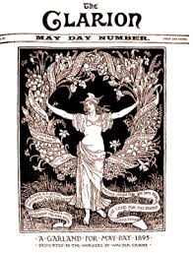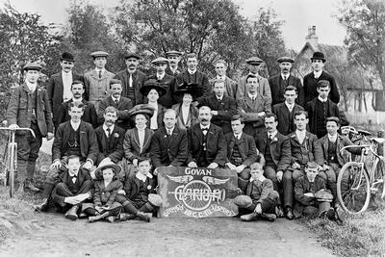
Robert Blatchford The Clarion paper Govan Clarion Cycle Club

From it’s beginning, the ILP never sought to establish a homogeneous ideology, but rather attempted to act as a broad left party of the working class, advocating a rather vague and amorphous socialist agenda. The ILP always maintained a strong orientation to trade unionists and had an ultimate object of tapping trade union funds for the attainment of Parliamentary power. The socialism of the ILP was ideal for achieving this end; lacking, as it did, any real theoretical basis, it could accommodate practically anything a trade unionist was likely to demand.

In a party of loose and diverse opinions, the issue of control and direction was subject to contest. By and large the branches sought to exert a broad democracy but the leading figures sought to control and direct as much as they could. Towards to end of the 19th century, the power of the National Council grew, and a strong leadership emerged around Hardie, Philip Snowden, an evangelical socialist and Christian from the West Riding of Yorkshire, Ramsay MacDonald (who came to the Party after he finally ditched illusions in the Liberal party around 1895), and Bruce Glasier, who became Chairman in 1900. Whilst there was some tension between these four, they shared the view that they needed to forge an alliance with the trade unions rather than an ideology-based socialist unity with the SDF. Pressure to form some form of left unity with the SDF and the Fabian Society grew after 1895, supported by Blatchford and the Clarion. In fact, a referendum of members of both organisations favoured unity but Hardie and the ILP leadership resisted, seeking instead to ally themselves with the Trade Unions and Trades Councils to create a different kind of unity. This eventually came to pass in 1900 with the creation of the Labour Representation Committee. This will be the subject of the next episode of this story.

