The Fabian Society
The Fabian Society was established a few years after the SDF. Its early inspiration was drawn largely from a socialist perspective, but it was reluctant to get involved with either other socialist groups or trade unions and veered, in its early years, towards seeking to influence the Liberal party, intellectuals and state administrators. Its character was essentially middle-class, London-centric and academic with a tendency to elitism as this quote from Beatrice Webb indicates,
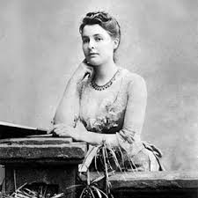
“Do we want to organize the unthinking persons into Socialistic Societies, or to make the thinking persons socialistic? We believe in the latter process. “

The story of the Fabian Society starts in 1883 when a number of people, mainly young and living in London, met in Edward Pease’s lodgings to discuss setting up a new association dedicated to reconstructing society along high moral lines. Some of them had already joined the Democratic Federation, others had flirted with the Fellowship of the New Life, which was established by a visiting American scholar called Davidson to promote ethical socialism. In January 1884, after months of discussion, they set up the Fabian Society, named after Fabius, the Roman general, whose tactics were based on the idea of waiting patiently for the right moment to strike. There were two competing strands to Fabianism from the outset, the practical and the visionary. The practical wanted to do something immediately and favoured research, writing and influencing policy. The visionary were concerned to formulate the long-term aims.

Two new, powerful members strengthened this initial group of adherents. The first was George Bernard Shaw, at that time a poor journalist with a strong rebellious streak and a mischievous sense of humour. He had been a member of the SDF and thought of himself at that stage as a Marxist but he disliked Hyndman and was doubting Marx’s theory of value and when Morris left the SDF to form the Socialist League he decided to move over to the Fabian Society. He joined in September 1884 and immediately became a dominant voice. The second important figure was Sidney Webb a civil servant at the Colonial Office. He had a brilliant mind, was already a friend of Shaw, but had only recently begun to accept the arguments for socialism. Shaw tended to be the man of ideas and verve whereas Webb was the practical, reformist voice, keen to see government run on more democratic and efficient lines. A third key figure was Edward Pease, who had been instrumental in establishing the Society and was its chief organiser.
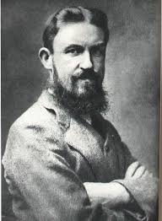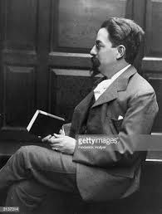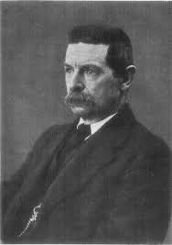
George Bernard Shaw Sidney Webb Edward Pease

Once Shaw had been persuaded to leave Marxism behind, the Fabian Society was able to coalesce around the Utilitarian dictum of seeking the greatest happiness of the greatest number, through state intervention rather than laissez-faire. Their approach was to seek to influence administrators and leaders by reasoned argument and good research. They also stressed that they were “constitutional”, which meant that they accepted the State (including the monarchy and House of Lords) and sought to work within it. Given this approach it was a grouping, which largely attracted the middle class and the intellectuals, especially in London.

They set out their stall by producing a series of tracts, the first of which was called, Why are the many poor? (1884). The second tract, also in 1884, was penned by G. B. Shaw and presents a manifesto of the Fabian Society.

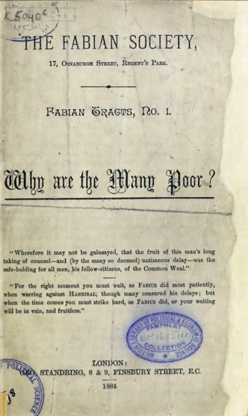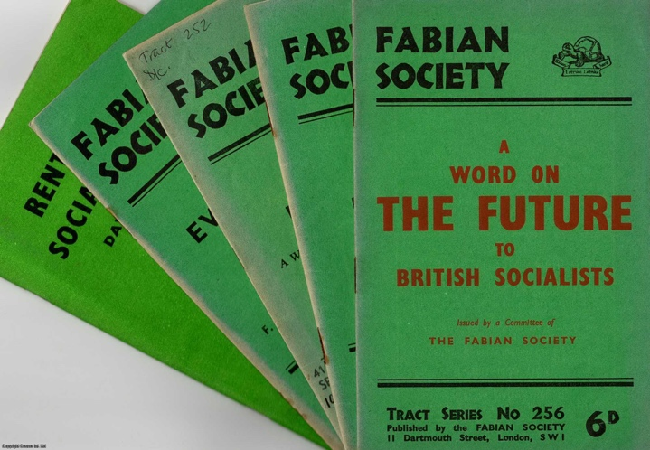
Fabian Tract No. 1 Fabian Tracts carried on after World War I

Shaw became the dominant figure in these early years, speaking widely and writing a great deal. But Sidney Webb had the more lasting impact, quietly working away at both policy research and developing ideas for improving governance and administration. The Society was tireless in preparing Fabian tracts and setting out facts and figures to support social and economic reform. A series of Fabian lectures in 1888 formed the basis for Fabian Essays in Socialism, edited by Shaw. This proved a big success and was re-printed many times.

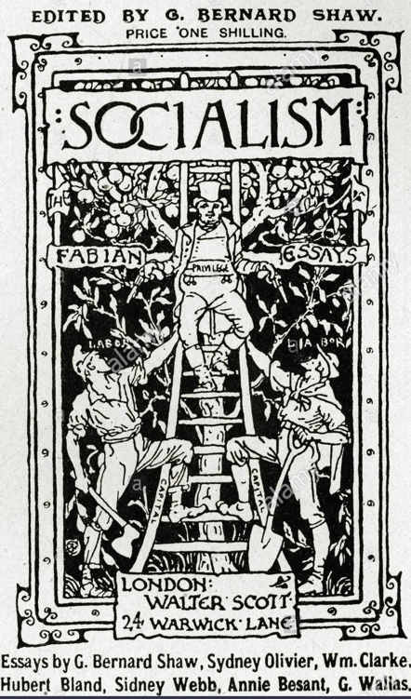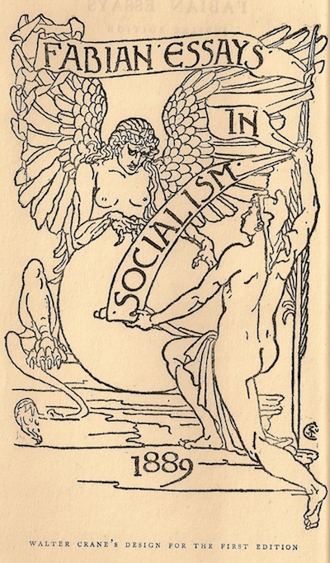

In terms of their political stance the early Fabians favoured a policy of “permeation”. That is, to influence the existing main parties, especially the Liberal Party, to adopt radical reforms at both local and central level by force of argument and evidence. The Liberal-Radical tradition was strong in London, where the Fabians were almost entirely centred. Radical Working Men’s Clubs thrived, and in 1886 a Metropolitan Radical Federation was formed and obtained representation at the annual conferences of the National Liberal Federation. The Fabians concentrated on the Radical Clubs, seeking to gain their support for their policies and programmes. The London County Council (LCC) was formed under the County Councils Act of 1881, and the Fabians helped the Liberal Party to form the Progressive Party to fight LCC elections in 1889. The Progressive Party won a majority of seats, and later Sidney Webb became one of their Councillors.

The Fabians also supported candidates for the London School Board elections in 1888, again achieving some success. They also made overtures to the Liberal press and won over H. W. Massingham, Assistant Editor of the Star.

In another initiative and under Webb’s direction the Fabian Society used a bequest to establish the London School of Economics in 1895. The School was to focus on being a centre of excellence for the social sciences, a relatively new area of academic study.
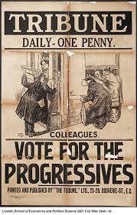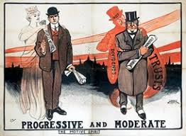
Election posters for the Progressive Party for the London County Council

The practical orientation of the Fabian work provided a basis for what became known as Municipal Socialism. The Society argued that many utilities and services operated by private concerns were inefficient and could be better run by local authorities in the interests of residents. This appealed to the increasing number of liberal and labour councillors up and down the country.

In terms of organisation, the Fabian Society remained dominated by London and generally uninterested in spreading its reach throughout the country. Despite this. a number of local societies did set up, especially in the Universities. However, in a bizarre reflection of the elitist approach of the Fabians, the University Branches were always deemed to be a part of the London Society and not Provincial Branches. The London Society took all the main decisions and although there were annual meetings when all members could attend, the power always remained with an Executive that was, to all purposes, chosen by the leading members in London.

There was a brief period when the Society decided to encourage a greater spread of membership and branches and by 1893 there were 72 in existence. However, by 1900 only 4 branches were reported as active.

Although the Fabian Society was not particularly interested in affiliating to other parties. it was tolerant of those of its members who became active in socialist organisations. It declined to send delegates to the founding conference of the Independent Labour Party (ILP) in 1892, but a number of provincial branches did so. In most cases these provincial branches left the Fabian Society and moved over to the ILP. However, by 1900 when the Fabian Society received an invitation to participate in the TUC’s new independent labour organisation, The Labour Representation Committee, it did agree to send as delegate, Edward Pease, its Secretary and also a member of the ILP.

