The Social Democratic Federation (SDF)
The oldest of the socialist organisations to help establish the Labour Party was Marxist in its broad orientation. The origins of the SDF lie in its forerunner, the Democratic Federation (DF). The key figure was Henry M. Hyndman, a radical Tory by upbringing.

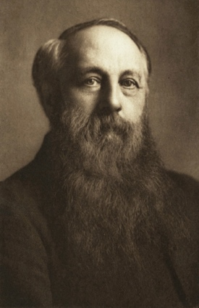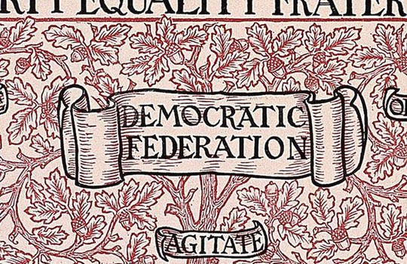
H. M. Hyndman The banner of the Democratic Federation

Hyndman had turned to socialism, after reading Karl Marx’s Das Kapital, in a French translation in 1880. He became convinced by the basic ideas of Marxism and sought out Karl Marx in London, where they held a number of meetings.

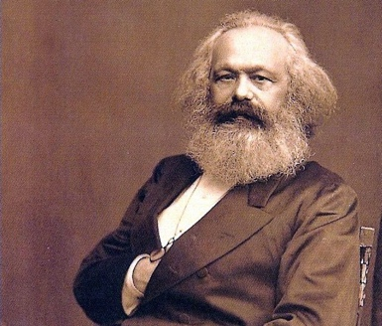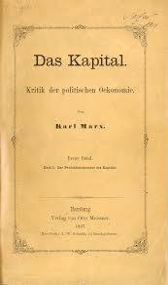
Karl Marx German edition of Capital Book setting out Marxist ideas

In1881 Hyndman had discussions with several prominent radical figures including old Chartists and members of the International Working Men’s Association (IWMA), also called the First International. Additional discussions were held with London’s Radical Working Men’s Clubs and Irish Associations. From this, it was agreed to form the Democratic Federation, and Hyndman wrote an initial book or manifesto, England for All (1881). In this he sought to embody the essential doctrines of Marx without acknowledging their source. Marx and Engels, already suspicious of this upper class convert, thereafter, would have nothing more to do with him. Many prominent socialists and radicals joined the DF notably William Morris and Eleanor Marx (Marx’s daughter), and some workers such as James MacDonald and Harry Quelch.

In 1883 the DF published a pamphlet, Socialism Made Plain which sold 100,000 copies and urged a number of practical reforms concerning housing, education, the eight-hour day, national banks and the gradual abolition of private banks, nationalisation of railways and land, organisation of unemployed under state control on co-operative lines and rapid redemption of the National Debt. At the end of 1883 members resolved to publish a weekly paper, and in January 1884 Justice began publication. Edward Carpenter and William Morris provided the necessary financial backing.

Hyndman was the undisputed leader and although a good speaker (even in his top hat!) and energetic organiser, was dogmatic and authoritarian. His grasp of Marxism was rigid and mechanistic and he understood none of the fluidity of Marxism embodied in dialectics. William Morris proved to be a tireless socialist and revolutionary, who wrote much for the paper, Justice and spoke up and down the country.

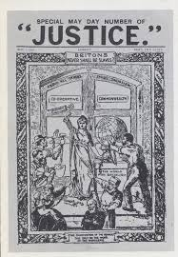
An early copy of Justice

In August 1884, the DF held its 4th Annual Conference and adopted the name Social Democratic Federation (SDF). Shortly afterwards there was a significant split when William Morris led a breakaway group called the Socialist League.

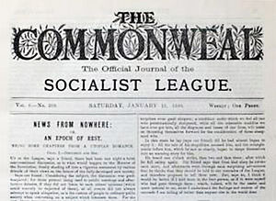
Newspaper of the Socialist League
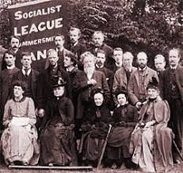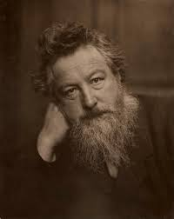
Hammersmith Branch of the Socialist League William Morris

One of the reasons the split occurred was the question of whether the SDF should stand candidates in elections. William Morris, Belfort Bax and others refused to accept a Parliamentary road to socialism at this time. They had also fallen out with the difficult Hyndman.

The SDF found it problematic to embrace both reform and revolution and tended to swing from one extreme to the other. At the point of the defection of William Morris and his group, the SDF opted to try to get Parliamentary representation. In this they were singularly unsuccessful and so in the late 1880s they put their emphasis into organising large demonstrations against unemployment.

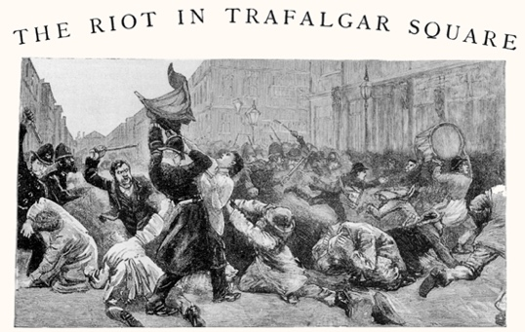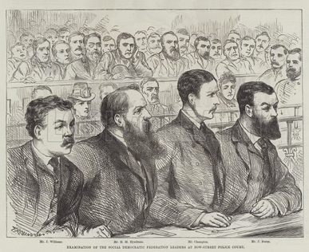
The Riot of 1887 Trial of SDF Leaders, including Hyndman and John Burns

The agitations against unemployment certainly gave considerable publicity to the SDF, especially after the trial of their leaders in 1887, and they were able to expand and develop a number of branches up and down the country on the strength of it. The demonstrations became more and more violent and the actions of the police and authorities more aggressive. The energy of this phase of street agitation began to fade towards the end of the 1880s. The SDF began, once more, to favour a more reformist and less insurrectionist approach. Although the SDF did not experience great membership growth in this period, it did exert a lot of influence up and down the country, especially among the new, militant trade unionists. Many future union leaders, such as Tom Mann, Will Thorne and Ben Tillett were members and owed much to the SDF. The SDF was widely recognised as the first socialist organisation in the period after 1880 and widely credited with spreading socialist ideas to a whole new layer of workers.

