4. The Socialist Organisations

Introduction
When the TUC Parliamentary Committee voted to establish a new independent labour organisation, it included in the organising committee not just the trade unions, but three socialist organisations. In order of seniority of establishment, these were: the Social Democratic Federation (founded 1881); the Fabian Society (founded 1884); and the Independent Labour Party or ILP (founded 1893). Each of these bodies will be considered in turn. But first it may help to set a slightly broader perspective by tracing the socialist movement as it emerged during the industrial revolution.

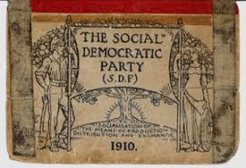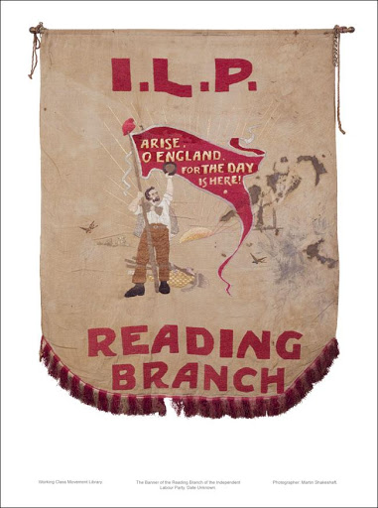

The socialist response to Industrial Capitalism
The rise of the industrial capitalist society produced a considerable wealth of writing and literature, offering critiques or commentary on the new system, and putting forward some ideas for its reform or replacement. This is not the place to go into the ideas of Spence, Ogilvie or Paine, nor the romantic poets such as Wordsworth and Coleridge, or prose writers such as Carlisle and Ruskin. But they all had their place in framing a response to the new society. They each also played a part in influencing public opinion, especially among advanced workers.

It is also important to note that the American struggle for independence between 1873-83, the French Revolution of 1789 and its aftermath, and the philosophical currents associated with Rationalist philosophy all contributed to the development of socialist thought and action.

The British working class initially relied on their own resources of resistance through strikes, machine breaking and attempts to form their own local organisations. However, when this largely failed, they moved on to the political stage to try to achieve universal suffrage. This switching in emphasis from what may be termed the economic field to the political one, and vice versa, in an attempt to seek solutions to their dreadful conditions, has been a continuing feature of working-class reaction to the capitalist system ever since.

One of the first socialists to have a significant impact on workers in Britain was Robert Owen. His views could be described as utopian socialist in that he thought capitalism would be surmounted by example rather than revolution or gradual reform. He achieved early prominence in his experiments in, what we may term, welfare capitalism at the massive mills at New Lanark, and from that experience went on to outline his wider ideas about a better society.

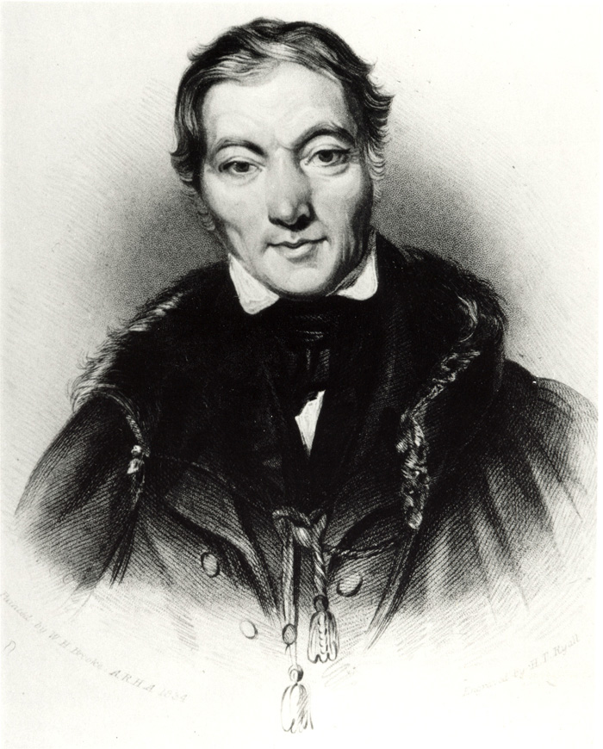
In 1813/14 Owen wrote an influential tract called, A New View of Society, in which he outlined his proposals for a new social and economic system based on co-operation rather than competition.

Left: Robert Owen

In the 1820s Owen tried to establish ideal model settlements in Britain, and later in the USA, based on his co-operative ideas. But none were a lasting success, and he returned home from America in 1829 to develop new ways to struggle.

In his last major initiative, he tried to form one all-embracing Trade Union: The Grand National Consolidated Trade Union, which was discussed in the last section on Trade Unions. Despite a lack of practical success Owen’s ideas inspired a significant number of advanced workers, and several Owenite societies and Owenite Halls of Science were formed in the industrial areas and these ideas later merged with those of the Chartists and other socialists who came later.
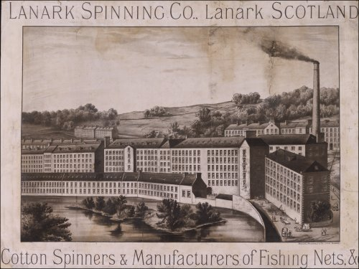

The Mills at New Lanark
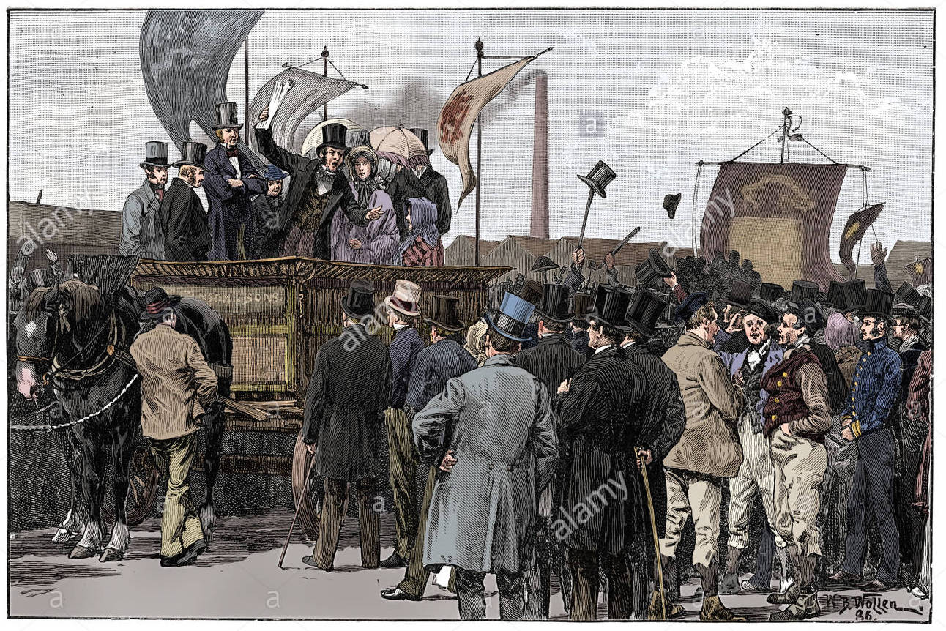
A Chartist Demonstration
But it was the idea of universal suffrage that took the main hold on the imagination of the working class in the first half of the 19th century. Massive demonstrations took place, seeking basic democratic demands from the 1830s through to the 1840s. These were organised by the Chartists. The work and ideas of the Chartists and its leaders deserve separate consideration elsewhere. Suffice it to say here, that the People’s Charter was a list of six key democratic demands. Massive petitions with millions of signatures supporting these demands were organised and presented to parliament. Most Chartists were also socialists and believed that if the vote was achieved then socialism could be achieved via Parliament.
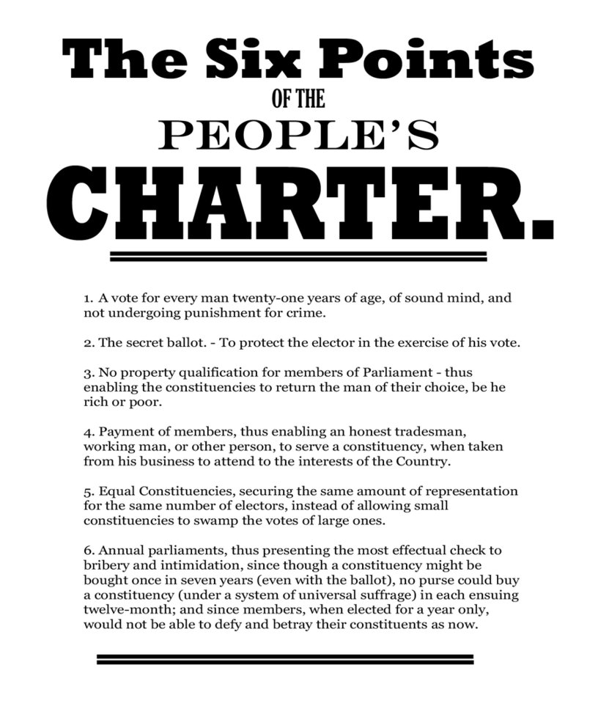
The early success of the 1832 Reform Act gave momentum to further agitation by Chartists for additional reform was fiercely resisted by the ruling bourgeois elite, and Chartism subsided along with the socialist movement generally.

The next revival of socialism occurs after the Great Depression of the 1870s and early 1880s, and it is in this phase that the new socialist organisations were born.

